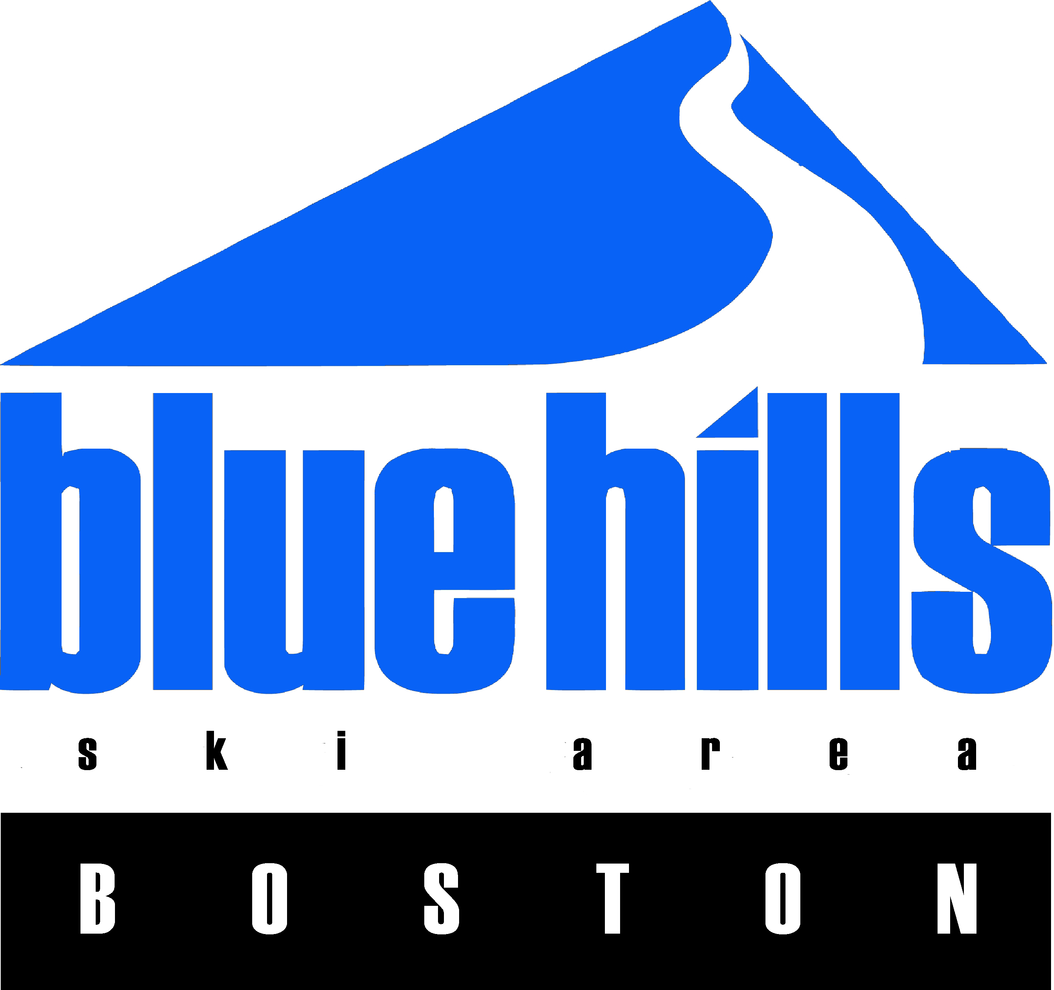
2021-22 JUNIOR PROGRAM RELEASE FROM LIABILITY AGREEMENT

I am aware and fully understand that cross-country skiing, skiing, snowboarding, snow tubing, snow blading and all other forms of winter mountain sports, including the use of lifts, is a dangerous activity/sport with inherent risks that may result in injuries and death. These risks include, but are not limited to, changing weather conditions, variations and steepness in terrain, snow or ice conditions, surface or subsurface conditions, bare spots, creeks and gullies, forest growth, rocks, stumps, the use of lifts, collisions with natural or man-made objects, other persons, grooming and snowmaking equipment, lift towers and other structures and their components, the failure of safety equipment and netting, whether or not properly installed, the setting and location of race courses, falling, loss of control, exceeding one’s ability, and conditions caused by the negligence of coaches, athletes, employees, directors, officers, agents, sponsors, volunteers and safety services personnel. All of the inherent risks of skiing, snowboarding, snow blading, snow tubing, and other winter sports present the risk of serious and/or fatal injury. I am also aware that riding ski lifts can be hazardous. I accept that it is our responsibility to ask for help from attendants if we are unfamiliar or uncomfortable with safe lift riding. I also acknowledge that, despite the preventative measures and safety protocols implemented by Blue Hills Ski Area, my presence at the ski area and/or participation in winter sports and other activities at the ski area entails a risk of exposure to or transmission of the coronavirus (COVID-19). I agree to comply with all policies and procedures implemented to reduce the risk of COVID-19 exposure, all posted instructions and restrictions, and all requests, instructions and warnings provided by attendants and other ski area employees regarding COVID-19 safety protocols. I also understand that courtesy and safe conduct on the slope is imperative for safe conditions at Blue Hills. Therefore, I accept that management reserves the right to revoke any participant’s ski privileges, without return of payment, if the participant commits any acts on the premises that are illegal, endanger the safety of himself/herself or others, and/or fail to comply with COVID-19 safety protocols.

In consideration of being permitted to participate in the activities offered at Blue Hills Ski Area, I, individually and on behalf of my heirs, executors, administrators, successors, agents, attorneys, assigns and legal representatives, hereby agree to release, waive, indemnify, discharge, and hold harmless Ski Blue Hills Management, LLC (d/b/a Blue Hills Ski Area), its agents, employees, directors, officers, shareholders and members of the National Ski Patrol and any and all ski instructors, whether volunteers or otherwise, (hereinafter, “Releasees”), from any and all liability for personal injury, property damage, illness (including but not limited to COVID-19), disability or death arising out of or related to the activities offered at Blue Hills Ski Area whether caused by the negligence of the Releasees, on or about the premises and facilities, the operations of the ski area including, but not limited to grooming, snowmaking, lift operations, actions or omissions of employees or agents of the area, or my participation in skiing, snowboarding, snow blading, snow tubing, other winter sports, or other activities at the area. I accept and assume full responsibility for any and all such damage or injury of any kind, which may result.

I understand and agree that this Agreement is governed by the laws of the Commonwealth of Massachusetts, and that if legal action is brought, the Commonwealth of Massachusetts has the sole and exclusive jurisdiction and that only the substantive laws of the Commonwealth of Massachusetts shall apply.

I also agree to abide by the terms of any rules of conduct for sports participants posted at Blue Hills Ski Area or contained in its seasonal trail maps or brochures, including but not limited to COVID-19 safety protocols.

I have read this Release From Liability Agreement governing the Junior Program at Blue Hills Ski Area and full understand its terms and understand that I have given up substantial rights by signing it, and have signed it feely and voluntarily without any inducement, assurance, guarantee or warranty, express or implied, being made to me and intend my signature to be a complete and unconditional release of all liability to the greatest extent allowed by law.

To the extent that I am signing this document on behalf of any minor, I represent and guarantee that I have the full authority to do so realizing the full binding effect of this Release From Liability Agreement on them as well as myself and further agree to indemnity and hold harmless the Releasees, from any claim brought by or on behalf of the minor relating to any personal injury, property damage, illness (including but not limited to COVID-19), disability or death arising out of or related to his/her participation in this group ski, snowboard, or other activity.

Participant Name

Parent/Guardian Signature Date

